**Introduction**

The document is taught how to setup database to make application can use.

**Details**

First. Database is MySQL.

You can click this link to download the application about MySQL Installation.

<https://dev.mysql.com/downloads/installer/>

When installs finish. Open the application and install some product of following image.

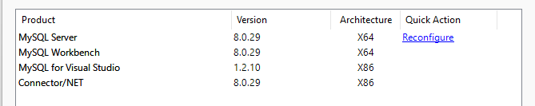

In installation, this will tell you setup the password.

Please remember and note the password.

Next, When all install finish. Open MySQL Workbench.

Please open this and input your password.

When opened, double click the “BetterLimitedDatabase.sql”, this file on the SDP folder. This path same the document.

When open the file, workbench will open same time.

Then, copy all text (Ctrl + A and Ctrl + C).

Next, go to server myself.

First, Click the red cycle of above image information.

Next, paste(Ctrl + V) all text to the black arrow.

Finally, Click the green cycle.

You will see your schemas has a new schemas database and all table.

After you finish above part, I will teach you how to make Visual Studio 2019 connect to database and make it can develop.

First, install Visual Studio Installation.

<https://visualstudio.microsoft.com/downloads/>

Download Community version.

Next, Open Visual Studio Installation, than click Visual Studio Community 2019, and select following image information. Then click download.

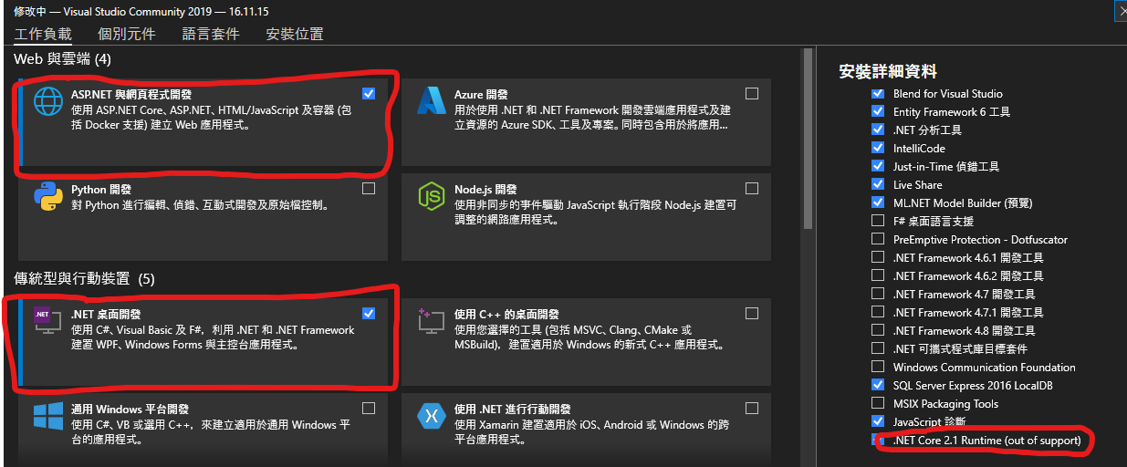

After install finish, open this. And open “WindowsFormsApp11.sln”.

You can see on right side like as following image.

The Model1.edmx and sdpDataSet.xsd is connect to database file.

About how to add this “Model1.edmx”

1. Right click the “In-store Computerized System”
2. select add, add project, select ADO.NET
3. Select next step, click new connect, select data source is “MySQL Database (MySQL Data Provide).
4. Input details, select database name.
5. Select table and then change name to “sdpEntities1”.
6. Click finish.

About how to add “sdpDataSet.xsd”

1. Click Shift + ALT + D
2. Then click up site add new data source.
3. Repeat add “Model1.edmx” step 3 – step 6.

I hope above information are useful to you, if you have any bug or question, please contact email 210094873@ stu.vtc.edu.hk